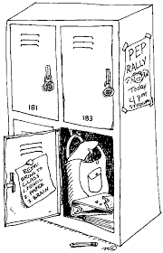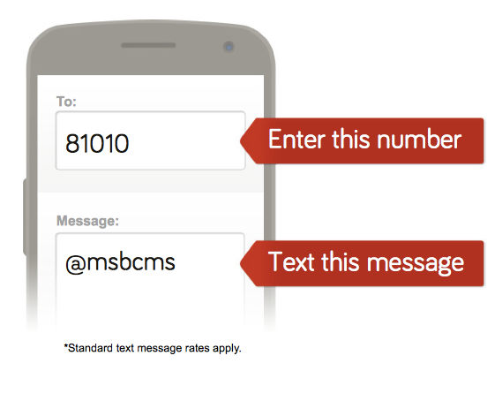

Welcome to BCMS!

Tips for a Successful Start to **6th Grade!**

**You will be asked to reply with your first name and last name. After doing so, you will be added to the 6th Grade Silver Team distribution list!**

Remind 101

Sign up to receive text messages reminding students and parents about **tests**, projects and upcoming 6th grade events

Lockers

-Combination Locks are recommended

-Practice opening your lock over the summer!

-Locker shelves are recommended for organization

Teacher’s Advice

-Be open to meeting new friends from other schools

-Bring a backpack to easily carry everything you need home

-Memorize & keep up with your schedule

-Fill out your agenda daily to prioritize & stay organized

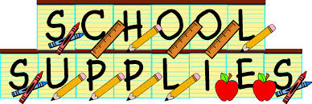

Language Arts

**Mrs. Schuhmann**

Paula.schuhmann@boyle.kyschools.us

* 3 ring binder:  1"
* Loose leaf paper
* Package of dividers

Science

**Mrs. Harris**

Julie.harris@boyle.kyschools.us

* 3 ring binder for science only; any size 1" or 1 1/2" is best
* Composition book or a spiral (100 page) book for science journal

Math

**Ms. Post**

Joanna.post@boyle.kyschools.us

* 3 Ring Binder (at least 2 in)
* 3 Dividers
* Graph Paper
* TI-73 Calculator

Social Studies

**Mr. Webb**

Dennie.webb@boyle.kyschools.us

* 3 Ring binder with pockets is recommended to keep handouts

General 6th

Grade Supplies

* Paper towels
* GermX
* Lysol or Clorox Wipes
* Tissues
* Pencils and Pencil Pouch
* Colored Pencils
* Highlighters
* Glue or Glue sticks
* Scissors
* 1 package of Post-it Notes
* Lose Leaf Paper